InMoov Robot Project

Update History
Dawson Green 06/13/2015

Contents
Project Summary 2
Needed Materials 2
Available Files 2
How to Use Cura 15.04 3
Main Interface 4
Opening/Saving Files 4
Printing Preferences & Print Quality 5
Editing Objects on the Print Plate 7
Finishing Up 9

Project Summary
InMoov is a life size, 3D printed, fully animated robot available under the CC-BY-NC license. It was designed by Gael Langevin and is maintained at http://www.inmoov.fr/project. At present, the current project maintained at Portland State University is to print and enable the full head component. The project will provide a platform for further exploration and experimentation with computer vision, motion and audio capabilities.

Needed Materials
Portland State University currently has an Ultimaker 2 available for printing of components. The currently printed materials have been printed using this system on “fast mode”. A tutorial for this software is included later in this document.

The website maintains a full list of necessary parts. Based on construction directions, this parts list has been pared down to only what is needed for the head and (possibly) neck. Where available, parts have been priced via Amazon.com for reference. Prices may fluctuate. Use your best judgement on purchasing parts based on what you actually need and can afford.

DATE OF LAST PRICE CHECK – 06/13/2015
- 1 – Arduino Mega Board ($21.99 + $4.98 S/H)
- 1 – Arduino Servo Shield ($21.98)
- 1 – HS-805BB Mega Giant Scale Servos ($42.98 each)
- 1 – MG995 Standard Mini Servos ($9.99 each)
- 3 – DS929HV Servos (???)

Additionally, you will need 2 webcams to implant for the eyes. The designer recommends partially disassembling 2 “Hercules Twist” webcams, but some experimentation may yield a better choice.

Available Files
A condensed set of files has been included with this zip file, and should provide everything you’ll need to have printed to get underway. If something seems missing, please check the main repository online at https://www.wevolver.com/gael.langevin/inmoov-robot/head-and-neck. Files provided are from the “Skull & Ears”, “Face & Jaw”, and “Eye Mechanism” sub-directories. Software can also be downloaded from elsewhere on this repository tree as well.

How to Use Cura 15.04
PSU currently maintains a lab that is equipped for 3D printing parts needed for this project. It is located in the Electronics Prototyping lab (room 84) in the basement beneath the Engineering Building.

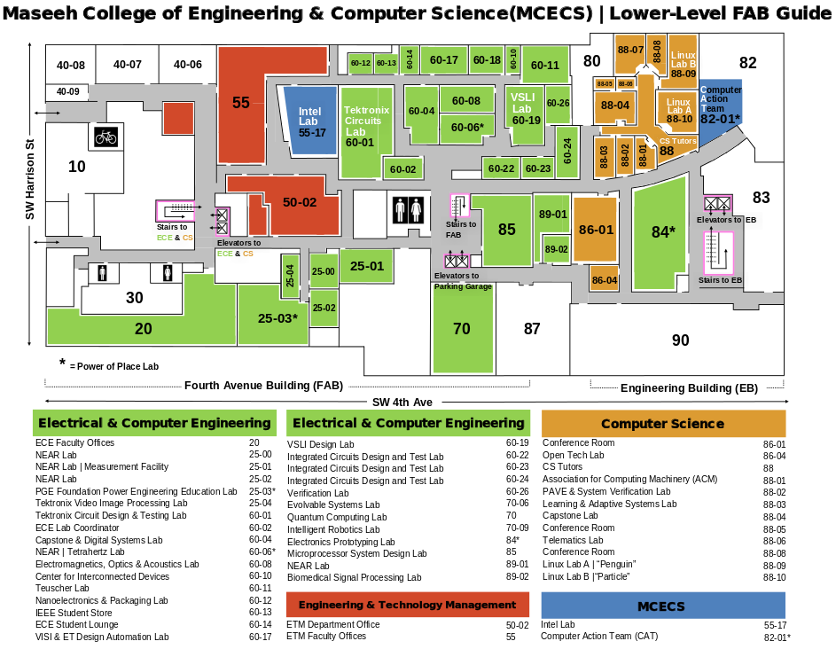

All parts for this project are being printed on the Ultimaker 2, a quick and inexpensive 3D printing platform. Parts printed on this printer must be loaded onto an SD card in “gcode” format. This gcode is generated using Cura (https://software.ultimaker.com/), an open source prototyping software that allows you to generate settings and printing directives for anything you wish to print on the printer. This brief tutorial will give you some notes for both moving around in and using Cura once you get it installed.

Main Interface
When you first open up Cura, this is the sight you will be greeted with:

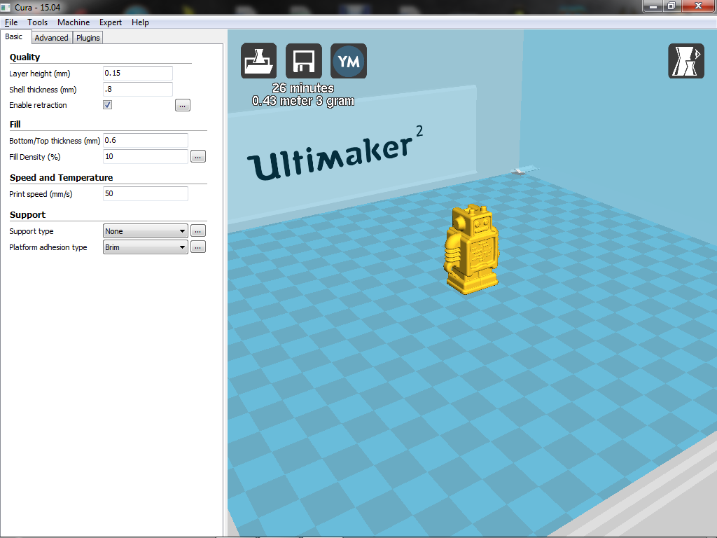

Cura will open both amf and stl file types, which then render the object on the virtual print bed. You can move around the print bed by holding shift+rightmb and moving the mouse around the screen. You can zoom in by either using a mouse wheel or holding leftmb+rightmb and moving the mouse forward/backwards. You can pan around your current focal point by holding rightmb and just moving the mouse around in the direction you want to shift your view. This will allow you to get zoom in on your objects and make sure you know how the Ultimaker will actually print it.

Opening/Saving Files
Files can be opened in two ways: by selecting “Load Model File” from the File menu tree or by double clicking it from the main OS window. Files are always loaded into the most recently opened instance of Cura, which can be useful for combining files. If you need a new instance and don’t want to clear the layout of this one, just open a new copy of Cura and you can then pull new objects into the fresh instance.

Cura is capable of saving files in 3 types:

- AMF format
The AMF format is the basic file save type for rendered objects, but cannot be printed. It has the virtue where, if multiple objects are loaded onto the platform, they will still be separated when you reopen the file.

- STL format
The STL format is virtually identical to AMF, except that saving this merges the objects on the print platform into a single entity. If you have very precise object spacing, this is useful as it will be preserved the next time you open the file. However, you will need to resplit the object in Cura if you ever want to change that spacing. All files for the InMoov robot are in STL format.

- GCODE format
GCODE is the actual printing file definition. This saves machine and print settings, as well as directions for the print nozzle. This file can be loaded onto the SD card for printing on the Ultimaker. Note that you can open GCODE files, but you can only review what the layer printout will be. No further changes, including adding additional files, can be made.

Printing Preferences & Print Quality
Under the file menu, there is an option to “Open Profile”. This refers to the printer settings which will define the quality of your print. Higher quality prints will obviously look nicer, but will take exceptionally more time and material to achieve. Most prints already take around 4 – 12 hours using the adjusted “fast print” settings that have been drawn up, and the quality seems to be acceptable for the time being. However, if you need to adjust the settings, you can do the following:

- Start by going to the “Expert” menu and switch to “quickprint” mode. The controls on the left side of the screen will change to look like this:

- Select the general setting you want, and then return to the expert menu and switch back to full settings. The system will ask if you want to copy your settings, so select “yes”.

- If you selected “Fast Print” from the previous screen, this will be what you see in your print controls. We’ll go through and explain each option.
  - Quality
This has the most general control over how long it will take to print and how good it will look.

The layer height can be changed to be between 0.04mm and 0.25mm. The smaller the layer height, the more layers there are and thus the longer it takes to print. However, smaller layers means curves are better approximated, so it also generally makes it look better. It is generally not advised to go above 0.15mm.

Shell thickness should be set to a multiple of 0.4mm (it is highlighted yellow because that value will print, but not very well). This makes sure that the outer shell of the print is solid enough to not break. For multiples larger than 0.4, this will create horizontal zones that are fully filled in, instead of being proportionally hollow due to a low fill density (see below). 0.8 is usually a good value here.

Always enable retraction. This will keep material from gooping around the print.

  - Fill
This will define how much material is actually used inside the part.

The very top and very bottom layers are printed with a special thickness since they are actually edges. 0.6 has been found to be acceptable so far, so only increase this if you are also increasing the shell thickness or have seen the part break.

Fill Density will keep the part from being too bendable (unless you want that). We’ve found that 30% fill density gives reasonably solid parts without adding too much to the print time. However, if you need to make it solid, make this 100.

  - Speed and Temperature
This value keeps getting tweaked and played with. Generally, slower printing gives the plastic more time to settle, but faster printing gets it done, well… faster. Check with the lab techs on what speed they recommend for the print. They may just say to go with the default, in which case 50 mm/s is fine.

  - Support
This sets up what the ultimaker is going to need to do to help get the print to look right.

Support is needed if you have a “steep angle” hanging in mid-air. The obvious example is if you were printing a window frame vertically: when you got to the top of the frame, the nozzle would be trying to print over open air unless you had something for it to rest on. A lot of the time, you can fix the need for support by rotating the part. However, if you can’t, you’ll need to enable this and tweak the settings available under the “…” button. If you need help with this, check with the lab techs, as they’ve developed a good intuition on what you’ll need for printing.

Currently, all prints on the PSU ultimaker should use a “Brim” for platform adhesion. This causes some extra lines to be printed on the very first layer and helps anchor the print on the printing platform. It’s recommended to use between 10 and 20 lines for this brim.

- Your printer is now generally configured. Always check with the lab techs if you need to adjust anything under the advanced settings, but you probably won’t have to.

Editing Objects on the Print Plate
So now you’ve got the system set-up, the print options loaded, and you’ve finally loaded your object into Cura. You then facepalm because the designer let this happen:

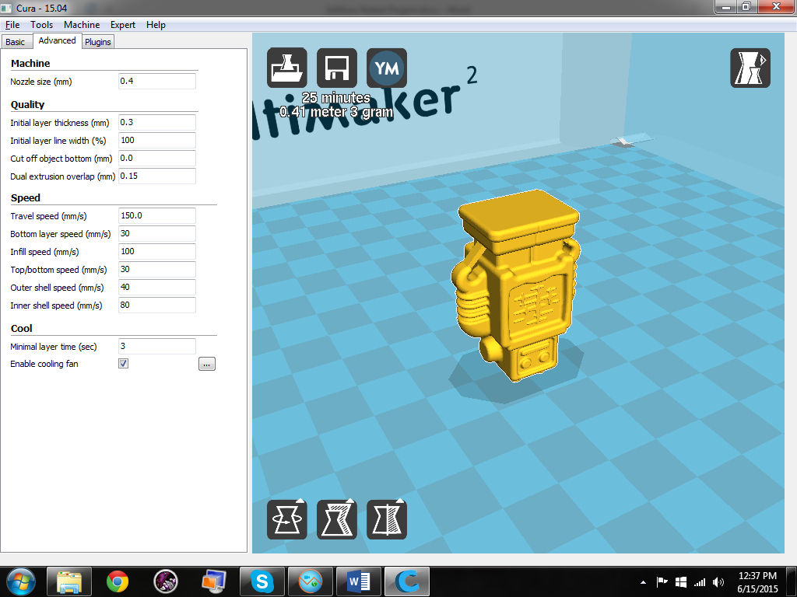
Well there’s your problem. Especially if you are printing multiple objects, sometimes you will need to adjust the orientation, position, or size of the object being printed. Fortunately, you can do that fairly easily.

Position, for instance, can be changed by just clicking the object and moving it around the plate. If you move it into the printing zone of another object, the system will budge the object you don’t have selected and try to make room. Only objects highlighted with the “model color” under the File->Preferences option set are actually going to be printed. If it’s grey, it won’t be printed. The system will also lie a little bit: the squares used to define the print area aren’t all accessible by the nozzle. Generally, you should keep at least 1 or 2 rows between the edge of your object and the edge of the plate.

Other modifications can be made using the three icons at the bottom left of the image above.
The rotate option will cause a series of circles to appear around the object. Grab one of the circles by holding down the leftmb and you can rotate it along that axis in increments of 15° at a time.

The scale option will let you resize the object if you need to. Something like the demo robot model shown in this guide can be resized without much trouble, but parts for InMoov probably shouldn’t be modified this way.

The mirror option will let you flip the selected object around the selected axis. So, for the screenshot above, that was done by just selecting “Mirror Z” from the context menu that pops up.

You can also get a feel for how the print is going to progress by adjusting the view mode. On the top right of the print preview, you can change the viewing mode to highlight different things that might be important to you. The most important of these is the layer view. This gives you a preview of how the printer is going to actually render your object and how the nozzle will move around. You can then look at it, layer by layer, and get a feel for if you’ll need to enable material support.

In that screen shot, yellow is the printed fill material, blue is where the nozzle is moving while turned off, green is an “inner layer” of the “outer shell” (see Quality up above) and red is the outer most line for the “outer shell”.

There are a few more options available if you right click on the print preview while an object is selected. These are mostly self-explanatory, but you should note that “split object into parts” will allow you to take an STL file and break apart the resulting merged file if needed.

Finishing Up
Once you have you think you have your full print ready to go, check the top left group of icons.

Cura will give you an estimate on how long it will take to print everything you’ve put together and how much material it will take to print it. If you’re satisfied with these estimates, click the save icon and export your gcode. If it’s too long or you think you can fit a few more things on there, then go back to fiddling with settings and adjusting the print preview.

And that’s all there is to it

